Day 15 - 03rd July 2025

Task 1:

Create a node for a tree and include a constructor (empty)

Hint 👍
A node which consists of 1 data part and 2 refs ( 1 Left ref and another right ref)

Solution:

class TreeNode {
int value;
TreeNode left, right;

TreeNode(int item) {
value = item;
left = right = null;
}
}

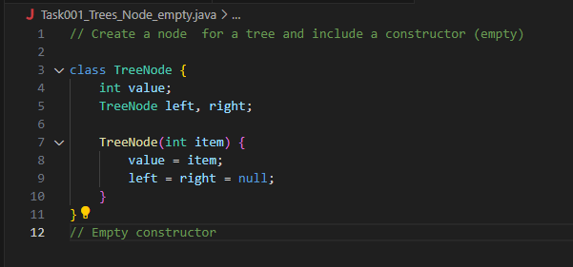
Task 2:

Create a class named Binary Search tree in which you have 2 insert operations

1 insert —----> for inserting if the tree is empty
1 insert —----> for inserting if the tree is 1 or more nodes

TreeNode insertVal(TreeNode node, int value) {
if (node == null) {
node = new TreeNode(value);
return node;
}
if (value < node.value) {
node.left = insertVal(node.left, value);
} else if (value > node.value) {
node.right = insertVal(node.right, value);
}
return node;
}

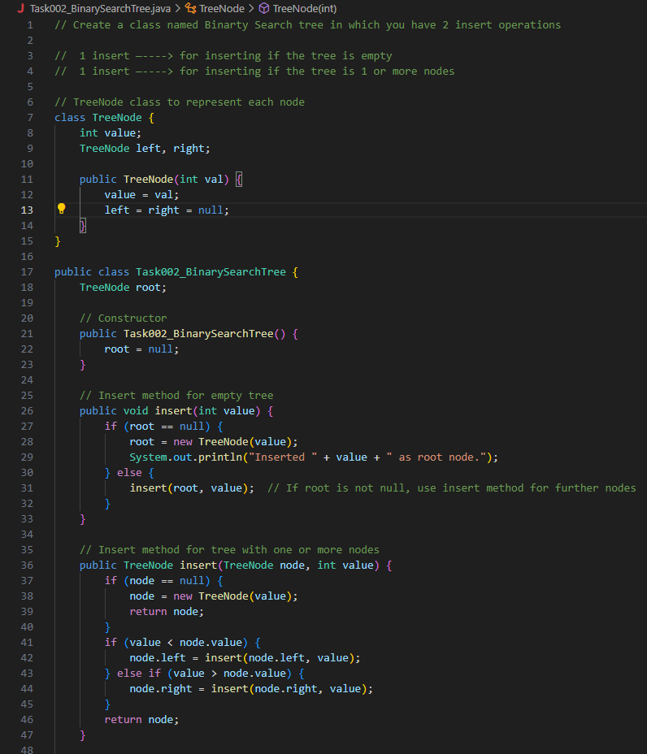

Task 3:

In order travel of the above code snippets from task 1 and Task 2
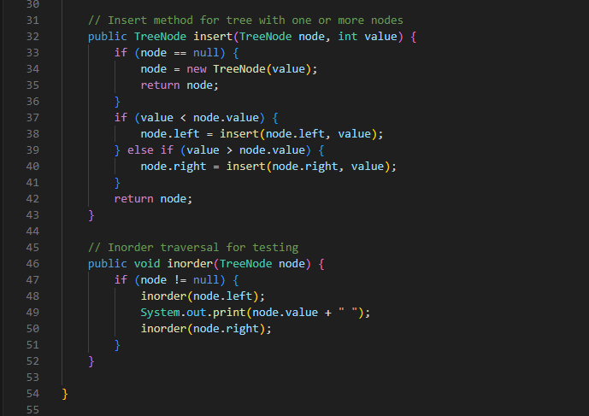

Task 4:

Create a main method Task 1, 2 and 3

And run the code..

Solution for Task 1 to task 4
In order Binary Search tree..

class TreeNode {
int value;
TreeNode left, right;

TreeNode(int item) {
value = item;
left = right = null;
}
}
class BinarySearchTreeOp {
TreeNode root;

void insert(int value) {
root = insertVal(root, value);
}
TreeNode insertVal(TreeNode node, int value) {
if (node == null) {
node = new TreeNode(value);
return node;
}
if (value < node.value) {
node.left = insertVal(node.left, value);
} else if (value > node.value) {
node.right = insertVal(node.right, value);
}
return node;
}

void inorder() {
inorderVal(root);
}

void inorderVal(TreeNode node) {
if (node != null) {
inorderVal(node.left);
System.out.print(node.value + " ");
inorderVal(node.right);
}
}
}

public class BinarySearchTree {
public static void main(String[] args) {
BinarySearchTreeOp bstobj = new BinarySearchTreeOp();
bstobj.insert(10);
bstobj.insert(50);
bstobj.insert(40);
bstobj.insert(70);
bstobj.insert(5);
Sytem.out.println("here is the code for in order traversal of Binary search tree ");
bstobj.inorder();
}
}

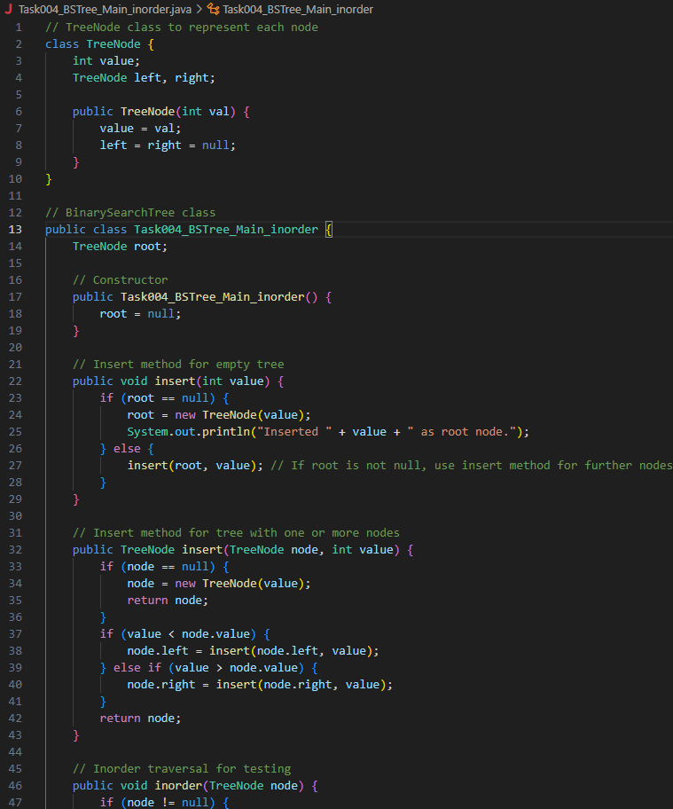

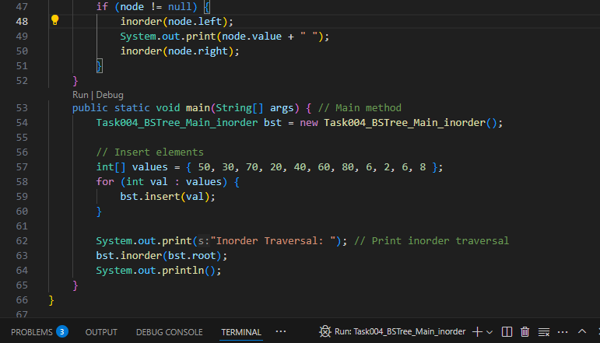

Tree Traversals (ways to visit all nodes):

📌 Inorder (Left – Root – Right)
- First visit the left child, then node, then right child.
- In BST, it gives values in sorted order.

📌 Preorder (Root – Left – Right)
- First visit the node, then left, then right.
- Used to copy the tree or display structure.

📌 Postorder (Left – Right – Root)
- First visit left, then right, then node.
- Used to delete the tree or solve expression trees.

📌 Level Order
- Visit nodes level by level from top to bottom, left to right.
- Uses a queue to process each level.

Task 5:

Applications of trees:

- Binary Search Trees (BSTs): Used in searching and sorting algorithms for efficient data lookup.
- Trie Trees: Power fast auto-complete and dictionary word matching.
- Heaps: Used in priority queues and heap sort.
- Syntax Trees: Key in compilers for parsing expressions and programs.
- Decision Trees: Used in machine learning for classification and predictions.
- File System Hierarchies: Directories are structured as trees.
- Network Routing Trees: Optimize paths between nodes in networks.
- XML/HTML Parsing: DOM structure is modeled as a tree.

Task 6:

Create a binary search operation on tree

Hint:
Create a node
Class for binary search

Solution 👍
class TreeNode {
int item;
TreeNode left, right;

TreeNode(int item) {
item = item;
left = right = null;
}
}
class BinarySearchTreeOp02 {
TreeNode root;

public BinarySearchTreeOp02() {
this.root = null;
}

public TreeNode search(int key) {
TreeNode current = root;
while (current != null) { // key 30 current 50 == root
if (key == current.item) {
return current;
} else if (key < current.item) { // key 80 current 50 == root
current = current.left;
} else {
current = current.right;
}
}
return null;
}
}

Task 8:

Types of Binary trees

1. Rooted Binary Tree
- Has a root node and each node can have 0, 1, or 2 children
- Basic form of any binary tree
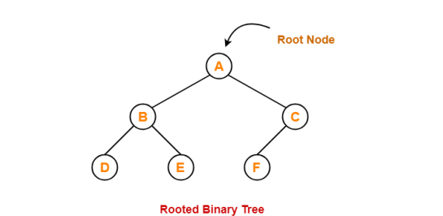

2. Full / Strictly Binary Tree
- Every node either has 0 or exactly 2 children
- No node in the tree has only one child
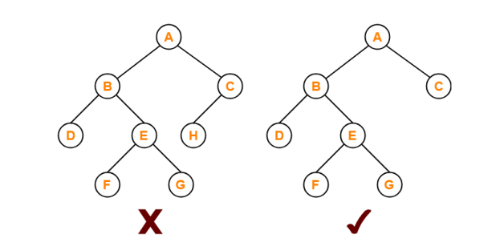

3. Complete / Perfect Binary Tree
- All levels are completely filled
- Each internal node has exactly two children, and all leaves are at the same level
- Highly symmetrical and balanced
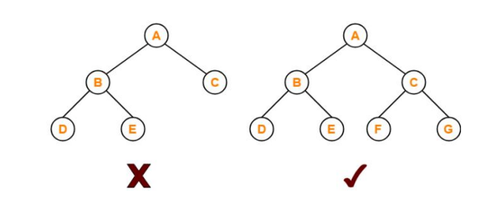

4. Almost Complete Binary Tree
- Like a complete tree except some nodes may be missing on the last level, and they are filled from left to right
- Commonly used in heap implementations
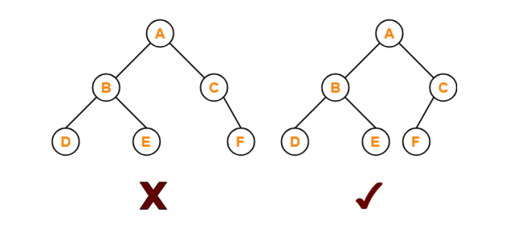

5. Skewed Binary Tree
- Nodes are arranged only on one side
  - Left-skewed: each node has only a left child
  - Right-skewed: each node has only a right child
- Visually similar to a linked list
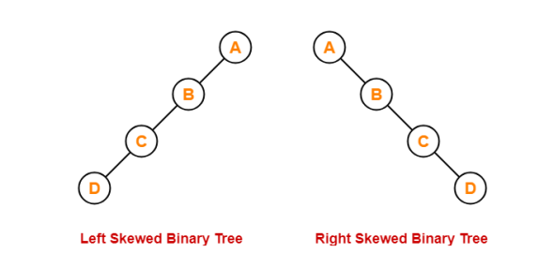
Difference between Strict Binary Tree & Complete Binary Tree

Feature | Strict Binary Tree | Complete Binary Tree
Children per node | 0 or 2 only | 0, 1, or 2 allowed
Node with one child | ❌ Not allowed | ✅ Allowed
Shape requirement | No strict shape | Must be left-filled
Last level | No special rule | Must fill from left to right
Example use | Tree structures | Heaps (like binary heaps)

Task 9:

Applications of Graphs

Real-World Applications of Graphs
Application Area | How Graphs Are Used
Social Networks | Represent users as nodes and relationships (friendships, followers) as edges
Navigation Systems | Cities/locations as nodes, roads with distances/weights as edges
Internet/Network Routing | Routers/computers as nodes; data paths as edges
Web Crawling/Search Engines | Web pages as nodes; hyperlinks as edges
Recommendation Systems | Products/users as nodes; preferences/interactions as edges
Dependency Resolution | Tasks or modules as nodes; dependencies as edges (used in compilers, builds)
Image Segmentation | Pixels or regions as nodes; similarity or boundary info as edges
Game Development/AI | Decision states as nodes; possible moves as edges (game trees)
Biological Networks | Genes or proteins as nodes; interactions or relations as edges
Electric Circuits | Components as nodes; wires/connections as edges

Task 10:

Types of Graphs:

1. Directed Graph (Digraph) Edges have direction (→). Example: Twitter followers (A follows B).

2. Undirected Graph Edges have no direction. Example: Facebook friends (A ↔ B).

3. Weighted Graph Edges have weights (numbers/costs). Example: Road map with distances.

4. Unweighted Graph Edges don’t have weights. Only connections matter.

5. Cyclic Graph Contains at least one cycle (a path that loops back).
Example: Circular routes.

6. Acyclic Graph No cycles.
Example: Task dependencies in project planning.

7. Connected Graph (Undirected) There’s a path between every pair of nodes.

8. Disconnected Graph Some nodes can’t be reached from others.

9. Complete Graph Every node is connected to every other node.

10. Sparse and Dense Graphs Sparse: Few edges, Dense: Many edges (close to complete)

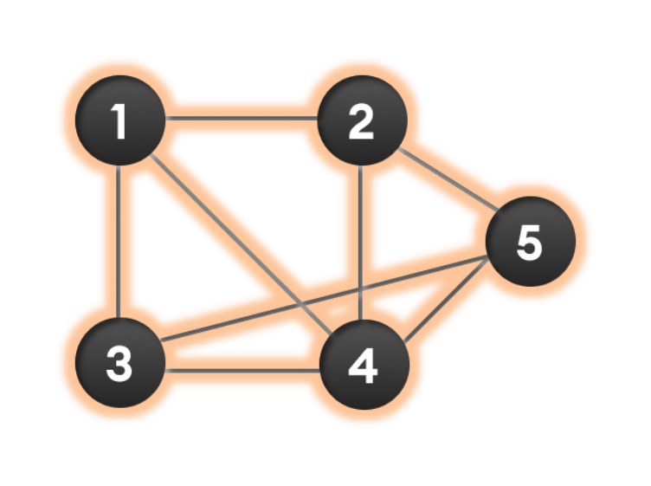

Wap to display a graph edges .in the below order no of edges 8 and no of vertex 5

1 - 2
1 - 3
1 - 4
2 - 4
2 - 5
3 - 4
3 - 5
4 - 5

Hint:

Class Graph{

Class Edge{
Int start/src;
Int end/dest;
}

Int vertex;

}

